We are what we drink:
Understanding drinking cultures
from the perspective of French Wine and Chinese Tea
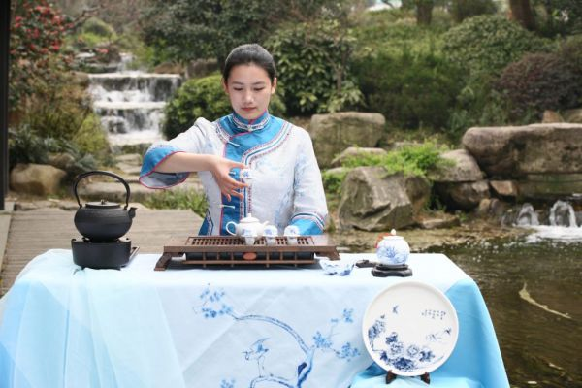
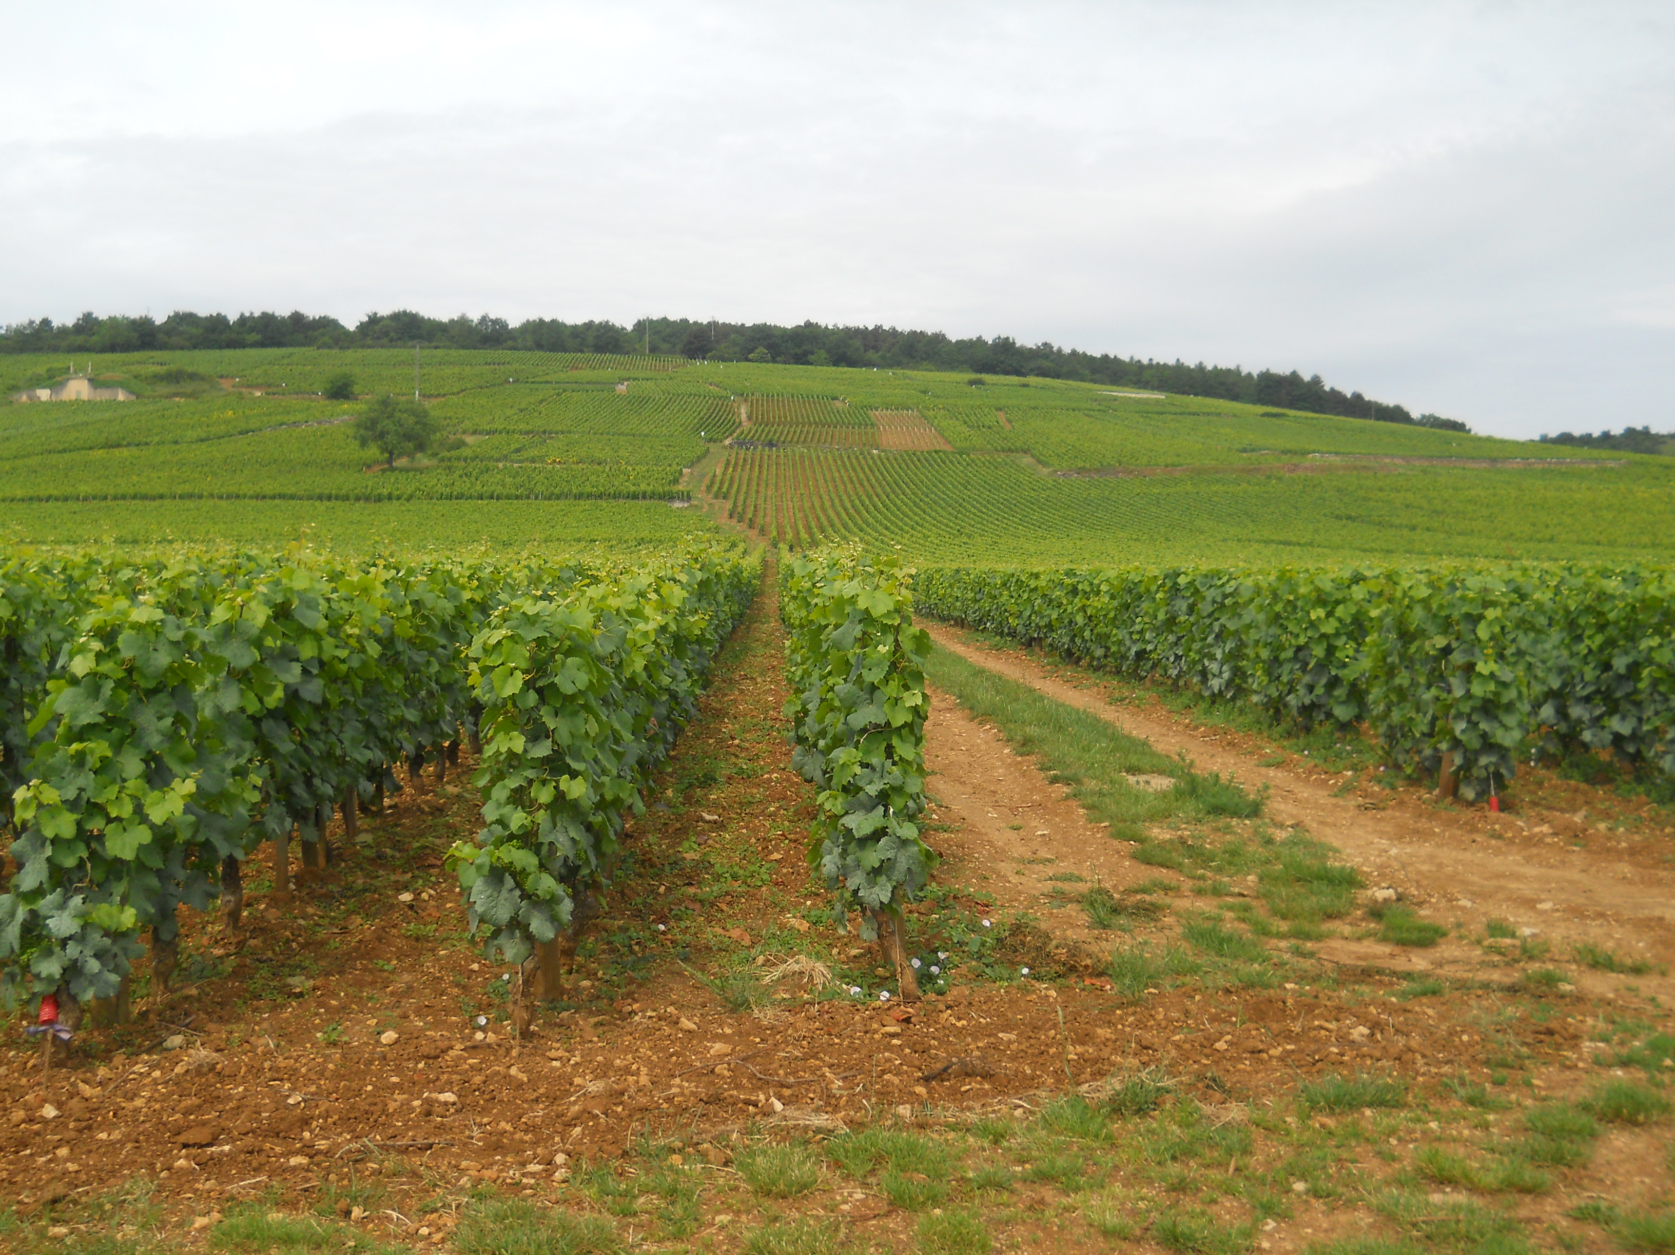
Saturday 11 March 2017
Avenue Campus
University of Southampton

Programme (provisional)

10.00 - 10.30 | Registration and coffee
10.30 - 10.45 | Welcome and introduction
French Wine
10.45 - 12.30 | From Terroir to Climats: Reinventing God’s vineyard  Professor Marion Demossier, University of Southampton  Inside Burgundy  Jasper Morris, Burgundy Director, Berry Bros. & Rudd wine merchants est. London  Introduction to Wine tasting
12.30 – 13.30 | Lunch
Chinese Tea
13.30 – 15.30 | Tea and Tea Culture in China  Dr Ping Chen, Zhejiang University  The Historical Evolution of Chinese Tea Drinking  Deputy curator, Researcher, China National Tea Museum  Tea ceremony  China National Tea Museum  Tea tasting
15.30 – 16.15 | Q & A Discussion:  What do French wine and Chinese tea culture have in common
16.15 | End

